**Don’t miss upcoming club meeting in the**

**College of Sciences & Mathematics**

|  |  |  |
| --- | --- | --- |
| Club | Next Meeting | Contact |
| American Association of Petroleum Geologists (AAPG) | Wed, Sep 11 @ 12pm Miller 326 | Bryan Byrd  byrdbf@titan |
| American Medical Student Association (AMSA ) | Tues, Sep 10 @ 7pm Miller 139 | Todd Hendrickson  hendrickts@gmail.com |
| Assoc. of Environmental & Engineering Geologists (AEG) | Wed, Sep 11 @ 12pm Miller 326 | Skye Schmuck  skyesch@gmail.com |
| Biology Club | Tues, Sep 10 @ 6pm Miller 139 | Mary Egwuonwu  maryegwuonwu@  gmail.com |
| Botany Interest Group | *To be announced* | Ancel Henson |
| Chemistry Club | Thurs, Sep 12  Chemistry 106 | Elizabeth Davis  Eidavis91@yahoo.com |
| Computer Science Club | Fri, Sep 6 @ 5:30pm  McGee 303 | Michael Morelock,  michael.t.morelock@  gmail.com |
| Math Club | Fri, Sep 6 @ 2pm  Math 101 | Chris Marsh,  Olivia Britton |
| National Prehealth Honor Society (AED) | *To be announced* | Nikki Kellerman |
| National Biological Honor Society (BBB) | *To be announced* | Marlena Alosi,  mvalosi@hotmail.com |
| Passion Driven Teaching (PDT) | Thurs, Sep 19 @ 6:30  Math 123 | Brittany Morton  mortonbn@titan |
| Pre-Dental Student Association (PDSA) | *To be announced* | Emily Benton  Emily.b93@hotmail.com |
| Society of Physics Students | Thurs, Sep 12 @ 5pm Miller 323 | Zack Williams  williamszg@titan |
| Student Nurses Association (SNA) | Mon, Sep 9 @ 7pm  School of Nursing | Amanda Finney  adnlsn88@gmail.com |

**Don’t miss upcoming club meeting in the**

**College of Sciences & Mathematics**

|  |  |  |
| --- | --- | --- |
| Club | Next Meeting | Contact |
| American Association of Petroleum Geologists (AAPG) | Wed, Sep 11 @ 12pm Miller 326 | Bryan Byrd  byrdbf@titan |
| American Medical Student Association (AMSA ) | Tues, Sep 10 @ 7pm Miller 139 | Todd Hendrickson  hendrickts@gmail.com |
| Assoc. of Environmental & Engineering Geologists (AEG) | Wed, Sep 11 @ 12pm Miller 326 | Skye Schmuck  skyesch@gmail.com |
| Biology Club | Tues, Sep 10 @ 6pm Miller 139 | Mary Egwuonwu  maryegwuonwu@  gmail.com |
| Botany Interest Group | *To be announced* | Ancel Henson |
| Chemistry Club | Thurs, Sep 12  Chemistry 106 | Elizabeth Davis  Eidavis91@yahoo.com |
| Computer Science Club | Fri, Sep 6 @ 5:30pm  McGee 303 | Michael Morelock,  michael.t.morelock@  gmail.com |
| Math Club | Fri, Sep 6 @ 2pm  Math 101 | Chris Marsh,  Olivia Britton |
| National Prehealth Honor Society (AED) | *To be announced* | Nikki Kellerman |
| National Biological Honor Society (BBB) | *To be announced* | Marlena Alosi,  mvalosi@hotmail.com |
| Passion Driven Teaching (PDT) | Thurs, Sep 19 @ 6:30  Math 123 | Brittany Morton  mortonbn@titan |
| Pre-Dental Student Association (PDSA) | *To be announced* | Emily Benton  Emily.b93@hotmail.com |
| Society of Physics Students | Thurs, Sep 12 @ 5pm Miller 323 | Zack Williams  williamszg@titan |
| Student Nurses Association (SNA) | Mon, Sep 9 @ 7pm  School of Nursing | Amanda Finney  adnlsn88@gmail.com |

**Convocation Map**

|  |  |
| --- | --- |
| **Department** | **Location** |
| Biology | Miller Science 234 |
| Chemistry & Biochemistry | Chemistry 106 |
| Computer Science & Information Technology | Miller Science 139 |
| Geology | Miller Science 302 |
| Mathematics and Statistics | Math Room 123 |
| Nursing | Miller Science 137 |
| Physics, Astronomy, Engineering | Miller Science 334 |

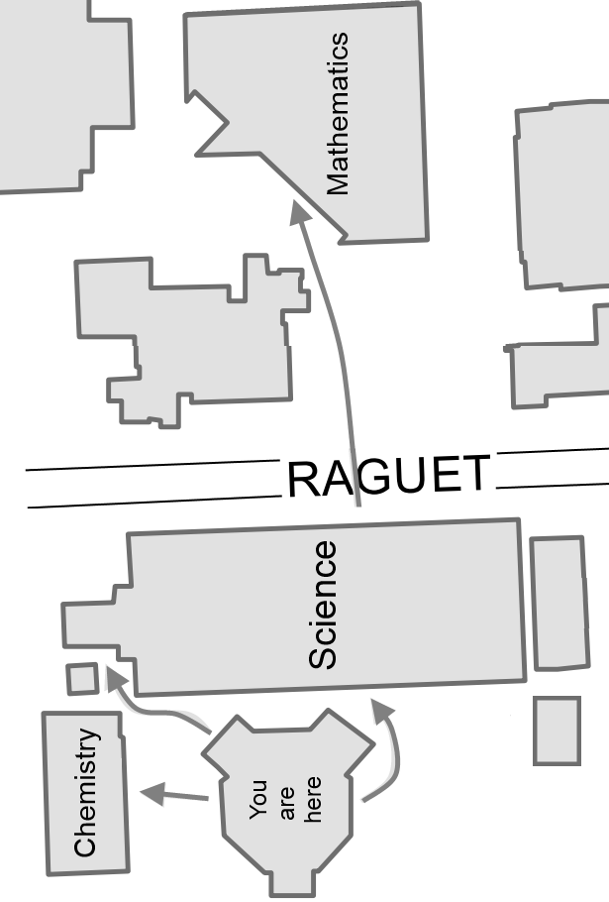

**Convocation Map**

|  |  |
| --- | --- |
| **Department** | **Location** |
| Biology | Miller Science 234 |
| Chemistry & Biochemistry | Chemistry 106 |
| Computer Science & Information Technology | Miller Science 139 |
| Geology | Miller Science 302 |
| Mathematics and Statistics | Math Room 123 |
| Nursing | Miller Science 137 |
| Physics, Astronomy, Engineering | Miller Science 334 |

